e 

SUPRA SAEINDIA 2024
DESIGN REPORT



Team ID : 35

Team Name : Velocity Vikings

College Name : PDPM IIITDM Jabalpur

City : Jabalpur, Madhya Pradesh

Report Author : <NAME>

Report Co-Author : <NAME>

I. ABSTRACT
IIITDMJ Racing is a fifth-year competitor in SUPRA SAE INDIA. Our team has designed “____________(car name)”and developed a highly efficient vehicle aimed at combining advanced aerodynamic modeling with cost-effectiveness and safety at top-most priority. The project began with the identification of key targets: optimizing fuel efficiency, minimizing environmental impact, and enhancing driver and passenger comfort, while maintaining strict adherence to safety regulations.
II. TECHNICAL SPECIFICATIONS
1.Dimensions:
Specifications | Measurements (in mm)
Length
Width
Height
Wheelbase
Front Track Width
Rear Track Width
Ground Clearance

2.Weight:

Items | Measurements (in kg)
Roll cage, Bodyworks
Suspension, Steering,
Wheels

Powertrain
Brakes
TOTAL
3. Chassis:Space frame chassis, truss structure, AISI
4130 Material.
4. Suspension:Front & rear: Double wishbone, non-parallel unequal arms, pushrod actuated.
5. Brake:Disc brake with fixed calipers. Mastercylinder connected in tandem.
6. Steering:Type: Rack & Pinion system.
7. Engine:Type: Single cylinder, twin cam shaft,
4 stroke engine with balancer shaft:
• Displacement: ____
• Stroke/Bore: _____
• Torque:______
• Power: _____
8. Drivetrain:
• Target __ th gear Speed is ___
• Final drive ratio is ____
• Synchromesh transmission box with open differential.
• Torque first gear:.____
9. Performance Targets:
• Safety
• Reliability
• Optimize weight
III. Design, Calculations
A. Frame Configuration:
• Seat:Seat back angle is ____ from horizontal & vertical
• Body and movement efforts:Fixed at___ for elbow bend,___for knee-bend & 90°for ankle- bend for extreme comfort.
• Pedaling:All pedals need to be pressed maximum by ___ to be fully activated which can be easily done with above configuration of driver’s position thus less pedal effort.
• Cockpit:Width of ___mm and length of ___ mm are obtained for driver’s comfort and smooth handling.
• Roll-Hoops:Main hoop leans rearwards by __° to obtain positioning of the seat along with head restraint system and firewall. Front-hoop leans forwards by __° to obtain the optimized position for the steering system so that driver can easily operate steering wheel with least efforts and maximum relaxation.
• Lifting and carrying:Extra tube at the rear lower end has been welded to easily lift and carry the vehicle using carry mechanism when there is very less clearance between vehicle and ground to avoid any kind of damage to lower portion of the vehicle.
• Shoulder harness:Shoulder harness is welded 595 mm vertically above the ground reference supported by 2 horizontal tubes of length mm along with 2 bracing tubes of length___mm which is then welded to the major structure. The specified configurations are chosen to get optimized position for the head restraint system, seat as well as firewall at the same time.
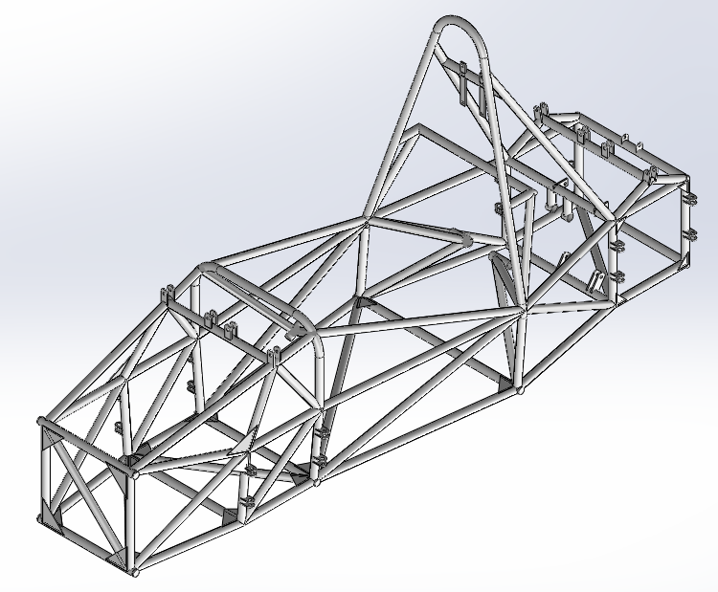
Design:
Roll-cage:Roll cage structure has been welded using _____________(type of weld) and electrode used is __.
The following list of design requirements are satisfied
by the chassis:
• Driver’s safety and protection:The chassis serves as the primary structural framework, absorbing and distributing impact forces in the event of a collision to minimize harm to the driver.
•Minimizing weight and low center of gravity:
By focusing on lightweight materials and optimizing component placement, we were able to significantly reduce the vehicle’s weight and lower its center of gravity, leading to enhanced performance, efficiency, and safety.
• Main-Roll-Hoop: Total 2 line-bends of __ are
Given to the main hoop on both sides where main
hoop is meeting with the major structure and 2 arc
bends of radius __mm is given at the upper
portion using manually operated bending machine
to make it smooth for safety purpose without
violating any rule. It leans rearwards by _.
• Front-Roll-Hoop is made up of total 3 pieces of
tubes. Total 2 line-bends__° are given to the
both side tubes where it is meeting with the upper
major structure. Another tube is horizontally
welded in between upper nodes of the side tubes. It
leans forward by __°.
Outer body covering:
Desired outer mold was created using putty mixture by applying it over polystyrene sheets which were given the required shape by sanding and grinding to get the stream flow design. Then the body was made using Fiber reinforced Plastic strength and rigidity to the body.
Parameters considered while designing the outer body:
• Minimum Drag, for better performance and fuel
efficiency of the vehicle.
• Maximum Downforce, to improve overall handling
and grip of the vehicle during cornering.
• We are providing a heat exchanger where
maximum heat is taken away through the radiator in sidepod
Shape and Configuration of the Body Components:
• Sidepod- Weight: __ kg, Maximum lateral length:
___mm, Maximum longitudinal length:___mm,
Maximum air flow through it:____kg/s. Shape is
such to prevent turbulent air from entering it and to
reduce formation of stalls due to flow separation.
• Front wings- Dual Airfoil setup with one foil
having a chord length: __mm & other foil having
chord length: __ mm, wing span:___ mm.
• End plates- Length:__mm, Height:__ mm.
Floor pan:Floor pan’s material is aluminum sheet of __ mm thickness with the set of ovals, extruded down grips in the form of set of cross pattern squares throughout pan.It is attached over the gussets, welded of lower base of vehicle with proper nuts & bolts.
Material selection:
• 1.3 mm thick Aluminum for underbody covering.
• 1.5 mm thick Aluminum for Firewall.
• Fiber Reinforced Plastic for outer body covering.
• AISI 4130 Chromoly alloy steel tube of 1.65 mm
thickness for frame work with outer diameter 25.4
mm.
• AISI 4130 Chromoly alloy steel tube of 2.5 mm
thickness for main hoop, front hoop and shoulder
Selection Procedure:AISI 4130 Chromoly alloy steel is selected upon 1020 Mild Steel to get comparatively higher Tensile/Compressive yield and ultimate strength with the same density and other adoptable properties. Ease of formability, allows us to achieve any 3d bending with the help of an ordinary piper bending machine operated manually.
From the strain data obtained in the analysis report, it is
determined that it is safe to use AISI 4130 frame tubing
of 25.4 mm outer diameter with a thickness of 1.65 mm
rather than 2 mm. This switch resulted in increase in
Safety-Factor and weight savings of approximately
16.2%.

PHYSICAL PROPERTIES OF AISI-4130
Density
Coefficient of thermal
expansion

Melting Point
Young’s Modulus
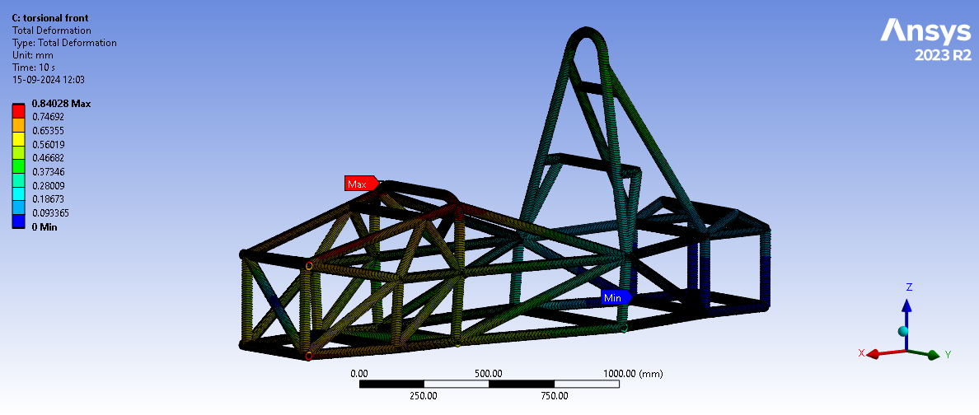

Img.F.1.Torsional Front(Total Deformation)

Img.F.2.Side I.A(FOS)

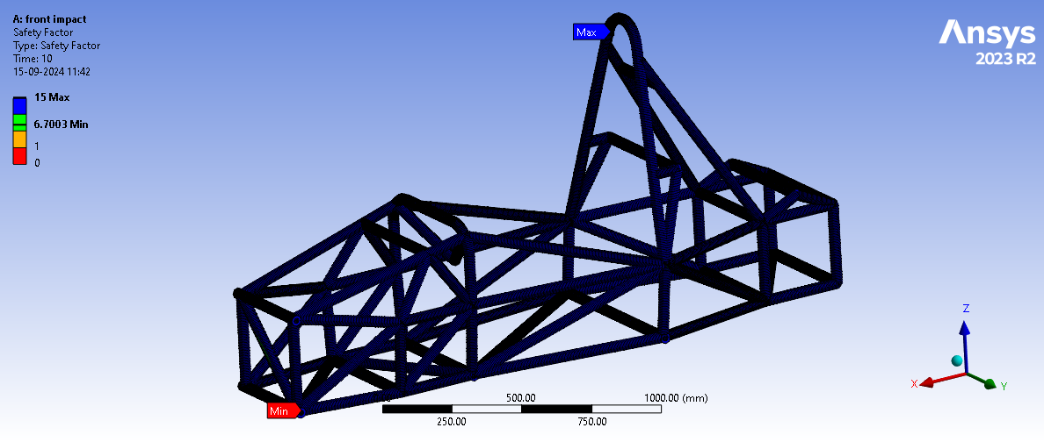

Img.F.3.Front Impact(FOS)

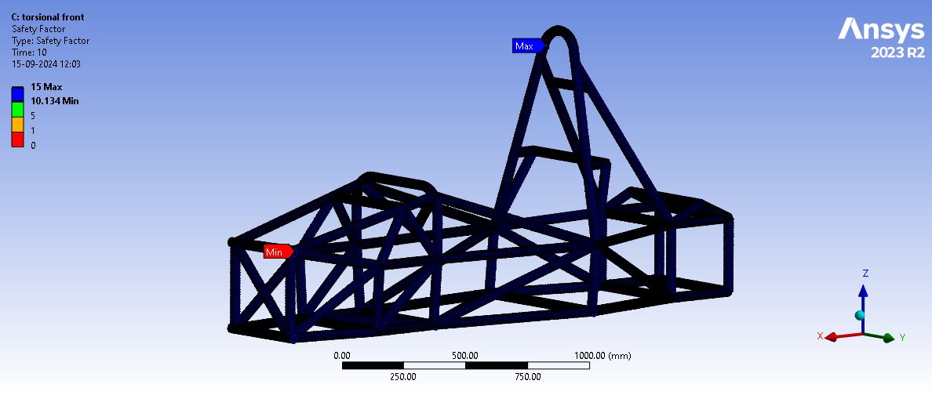

Img.F.4.Torsional Front(FOS)
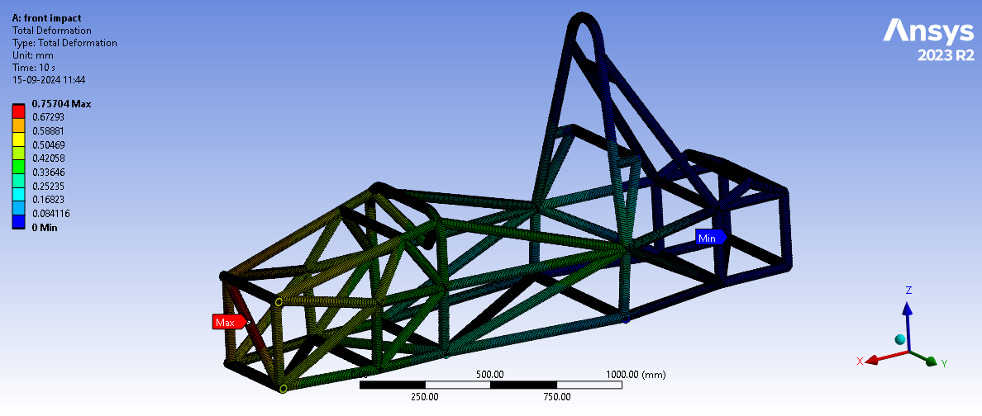

Img.F.5.Front Impact(Total Deformation)

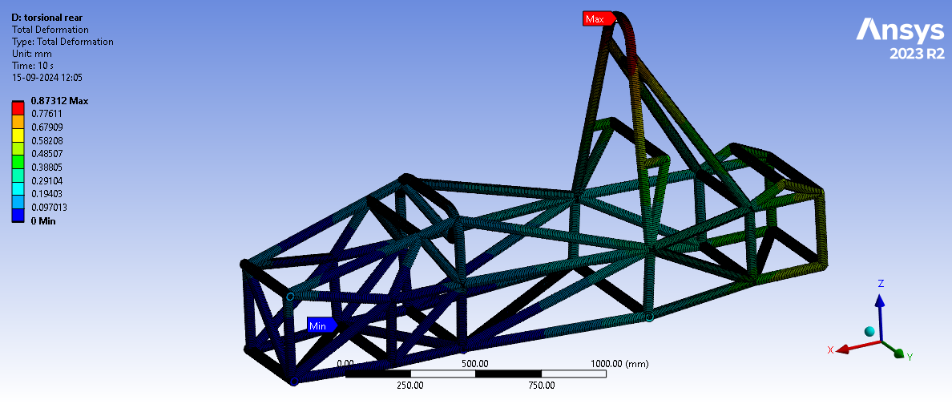
Img.F.6.Torsional Rear(Total Deformation)

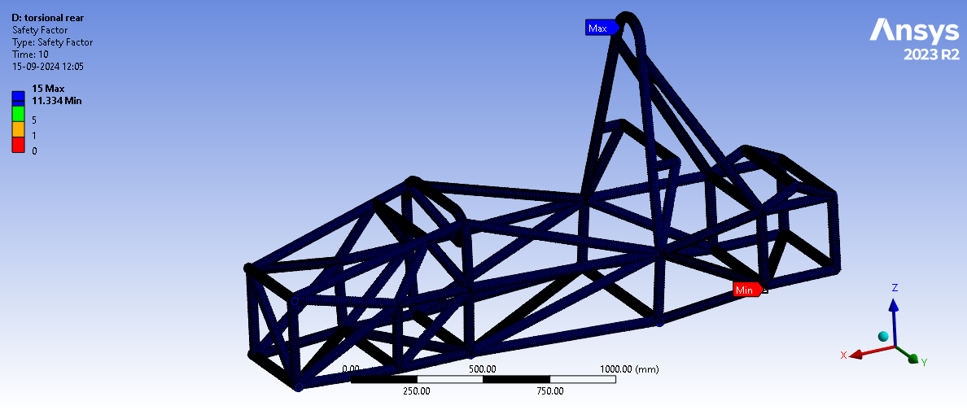

Img. F.7. Torsional Rear(FOS)

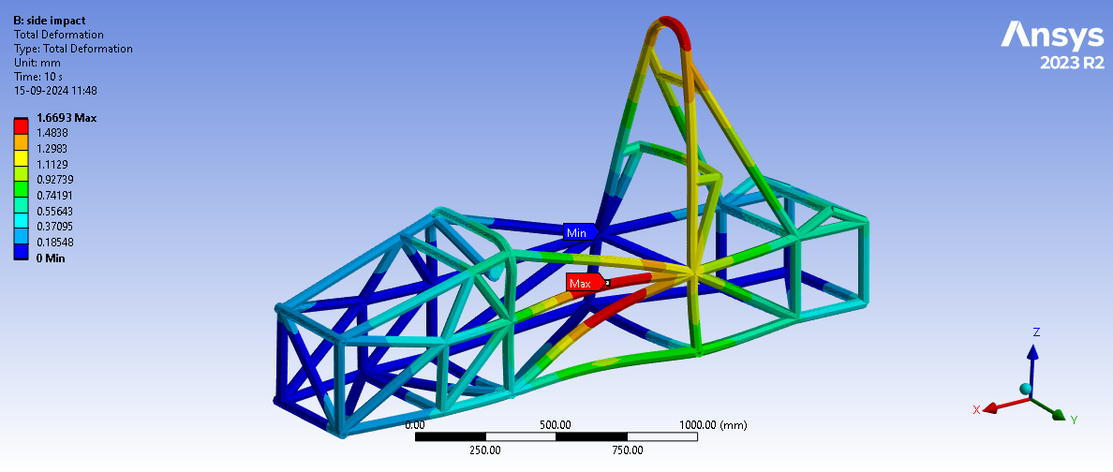
Img. F.8. Side I.A(Total Deformation)

Test | Boundary  Condition | Forces / Moments | Magnitude ~  Direction | Von Mises  Stress (V)  (MPa) | Deformation  (mm) | FOS  (V/Yield)

C. POWERTRAIN
Engine Selection:Our main objective for selecting engine is minimizing the mass and cost. And taking into consideration prescribed “Supra SAE” rules of limit of ___ cc and team’s limitation, we chose three engines that best suited our requirement.
•
•
•
On the basis of further study and literature review,
we chose____-engine.
Engine Details
TYPE: Single cylinder, twin camshaft, liquid cooled,
four stroke motor with balancer shaft
Displacement:
Power:
Bore/Stroke:
Idle speed:
Compression Ratio:
Liquid Coolant:
Air Intake System
It consists of:
1. TATA NANO Stock throttle
2. A restrictor of 20mm down the throttle.
3. A plenum to make the flow stagnant.
4. A runner down the plenum.

Plenum:Plenum: Spherical shaped plenum is considered and designed on the basis of manufacturing feasibility and laminar flow. The important factor in designing a plenum is the volume of the plenum. Performance of engine at higher speeds improves with increase in plenum volume.
Runner:Runner: Runner is designed to connect plenum with engine. The length of the runner is taken as 190.05
mm based on Induction Wave Theory.
Engine Mountings and Brackets:The Engine is mounted in the vehicle on the basis of
Nodal Structural Mounting using AISI 4130 pipes
which have been welded at the nodes from the chassis
and have been bolted into the engine for maximum load
distribution. Triangulation of the mountings has also
been done to ensure maximum load withstanding
capacity and to reduce unnecessary loading of the
brackets.
Fuel Tank
Fuel tank is fabricated keeping objective of reducing
weight and also being able to hold enough fuel to
complete one endurance event. Dimensions of filler
neck and side tube are strictly considered from the rule book. A final volume of —- is decided on the basis of
certain details obtained from the literature review:
Distance to be covered ( )
Average mileage ( )
—----------------------------- is chosen for fuel tank
because of its light weight, minimum corrosion
resistance, low price and fabrication ease in welding.
Fuel tank is mounted underneath the driver’s seat in the left side of chassis. In order to minimize sloshing effect while the car is in motion, 3 interior baffles (2
horizontal and 1 vertical) are used. A drainage hole is
incorporated at the base for draining the fuel.
Cooling System:Cooling systems are essential components of modern automobiles, playing a crucial role in maintaining optimal engine performance and preventing overheating. These systems are designed to dissipate excess heat generated during the combustion process, ensuring the engine operates efficiently and reliably.
Exhaust System:The exhaust system designed for the vehicle is “The Absorption Muffler” vehicular exhaust. The oxygen sensor used is Bosch Oxygen Sensor.
The Manifold length is ___cm with a diameter of
____ cm keeping efficiency and Temperature
Gradient into consideration. The Muffler length is 45
cm and a diameter of 11.43 cm with a perforated
pipe of same length hosed into it and wrapped
around with glass-wool (Sound Absorbing) material
and outer casing of Stainless Steel.
Differential:
Type: Open differential
Drive Ratio:______
Final drive ratio facilitates quick acceleration and
top-line speed.
DRIVE SHAFTS:Length of right side Half-Shaft is _______mm. Length of left side Half-Shaft is__mm.
After considering our requirements, limitations and
expectations from the Half-Shaft to be manufactured,
we finally came to a conclusion to use the AISI 1020
graded mild-steel as the most suitable material which
satisfies our constraints and gives most appropriate
results.
MOUNTING BRACKETS:After performing different simulations and iteration and taking various constraints into consideration we chose the below design of the brackets.

ESTIMATED TOP SPEED AND TORQUE:

Gear | Ratio | Maximum  speed  (km/hr) | Torque  (Nm)
1
2
3
4
5
6

CV JOINT:Traditional cv-joints are used to attach half shafts in the wheel hub.
These consist of Tripod which allows the axial
movements of shaft within the range. Movement of
suspension system requires uneven adjustments in
length of half shafts which is facilitated by the tripod
joints.

D. ERGONOMICS & AESTHETICS
Ergonomics:

Aesthetics:
E. Braking System
ROTOR AND CALLIPER SELECTION: KBX Vespa Single piston fhis fixed caliper is capable
of producing more than the requisite force on the rotors, while still remaining small enough for packaging .Disc rotors of YAMAHA RAY-ZR are used after reducing its diameter to 16cm, assuming coefficient of friction on discs to be 0.65.

Disc Rotor Diameter | 160 mm
Disc Rotor Material | Stainless Steel
Clamping Force on Front discs | 5322 N
Clamping Force on Rear discs | 5322 N
Required Clamping Force on Front discs | 3227 N
Required Clamping Force on Rear discs | 2749 N

MASTER CYLINDER AND
BRAKE LINES SELECTION:

Bosch Master Cylinder of Maruti Suzuki Omni with 15.75 mm Bore Diameter with cast Aluminum casing and 6 inches length of brake hose and lines is selected .we are using DOT4 Brake Fluid. Master cylinders are connected on the diagonally HConfiguration with two different Brake Fluid Reservoir

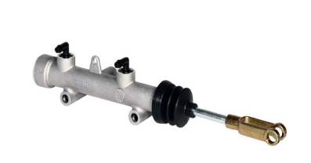

Fig. Master Cylinder

Force on the Front Master Cylinder | 712.5 N
Force on the Rear Master cylinder | 712.5 N
Pressure on Front Brake Lines | 4.03 MPa
Pressure on Rear Brake Lines | 4.03 MPa

PEDAL ASSEMBLY: The pedal system is designed to be a robust, light, and
adjustable set of pedals. It consists of brake, acceleration,
clutch pedals, master cylinder and master cylinder mount
and brake plate. After study about properties of different
types of materials and many ANSYS simulations, 7075 T6
Aluminum is the final selection as the material choice of
the pedal assembly

Maximum Force on Brake Pedal | 1000 N
Minimum Force on Brake Pedal | 475 N
length of pedals | 250 mm
Thickness of pedals | 30 mm
Pedal Ratio | 3:1
Factory of Safety | 5.03

F. SUSPENSION AND Wheel Assembly
Firstly, we decided our wheelbase and track-width on
the basis of rule book constraints and some general
standard data to be 1550mm and 1200mm (front track) and 1150mm (rear track) respectively. We have used BKT GF305 205/50-10 tires of size 10*18*6 wit
Capricorn Rim of size R10 in order to get more torque,
better control and stability by virtue of better traction
and usability in all seasons. Our criteria of design are
to keep the CG lower, lightweight of components,
safety and better aesthetics.
We have used push rod type double wishbone unequal A arm suspension system in both front and rear to get less drag and to avoid unnecessary turbulence in air path and to support vehicle’s aerodynamics and also to help in smooth actuation of vehicle suspension. To handle the kinematics of the vehicle, we needed to finalize the suspension points and to calculate parameters like roll center height, anti-dive and anti-squat feature, camber angle, castor angle, kingpin inclination, scrub radius, toe angle for the vehicle. For roll center height, we have considered major factors which affect stability and control of the vehicle the most, such as camber change rate, jacking effect, wheel scrub and vehicle rolling moment, and given them weightage according to their importance in stability and control. Hence the value for roll center height in both front and rear was calculated to be 53.926mm and thus the roll axis.
We have given an anti-dive of 10.3% in front and
anti-squat of 15% in rear to give the anti-feature to the vehicle.
Percentage is decided by the fact that the system should not be inactive. Front anti feature is given less with respect to rear to reduce the castor change rate of the wheels, which reduces the control of the driver on the vehicle in case of cornering. By hit and trial method and initial guess was set as parallel A-arms and further
modifications were done in order to achieve the desired values. By changing points by slight values, different changes in graphs were obtained in Lotus Shark, which were showing camber change, castor change, RCH change etc. which were needed to be optimized.
By the setting of our spring dampers, roll rates were
fixed and hence the angle of vehicle in dynamic
conditions at cornering was obtained to be 1.780 and
hence the static camber was decided to be the same as
car angle at corners, to utilize the stability feature of
camber angle at corners. A similar procedure was
followed for castor angle and kingpin angle and hence a camber angle of -20 and castor angle of +70 was decided. Scrub radius was taken from standard FSAE data to be +15mm. No Toe in/out was given to either front or rear wheels as our geometry was not needing it. Ground clearance was decided —mm as per constraints to keep the CG low.

Fatigue Analysis of A arms:

i) Front Upper A arm (left) :
Loadcase Considered : Max Turn
Loading Type : Zero Based
S.No | Position | Magnitude of force(in N)
1 | Fore member | 1132
2 | Aft member | 149
3 | Push Rod Mount | 1408

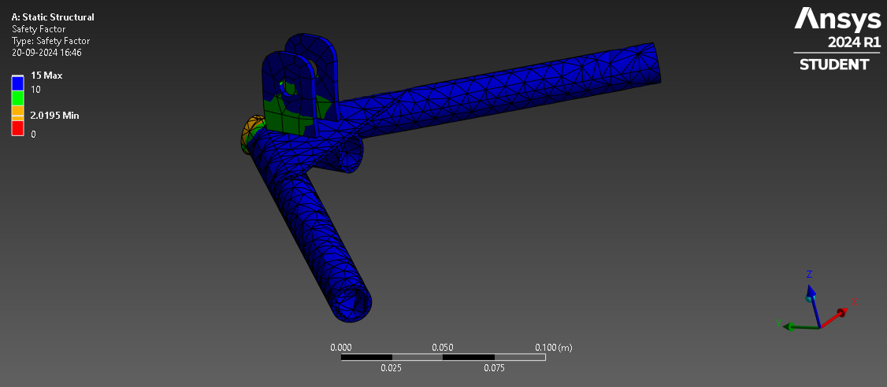

ii)Rear Upper A arm (left) :
Loadcase Considered : Combined Loading
Loading Type : Zero Based
S.No | Position | Magnitude of force (in N)
1 | Fore Member | 3221
2 | Aft Member | 396
3 | Push Rod Mount | 2201
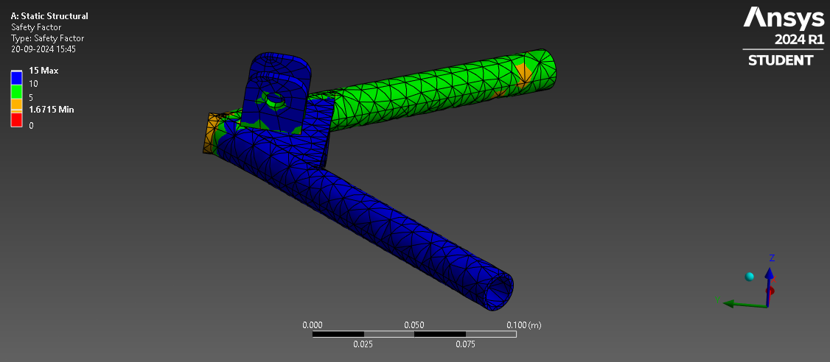

iii) Front Lower A arm (left) :
Loadcase Considered : Max Turn
Loading Type : Zero Based
S.No | Position | Magnitude of force(in N)
1 | Fore Member | 2833
2 | Aft Member | 3103
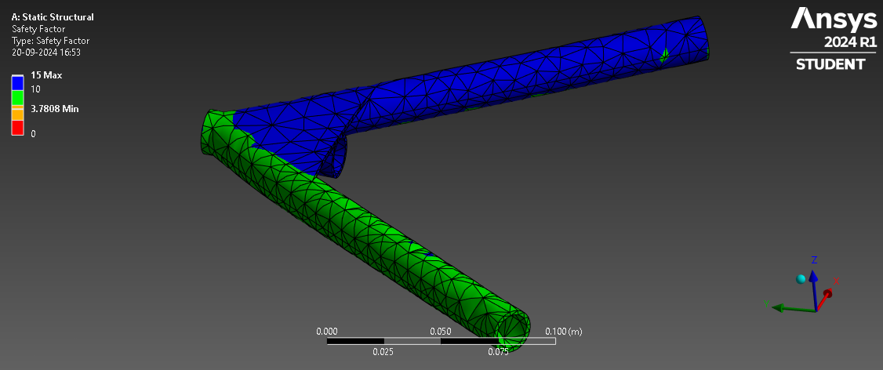

iv) Rear Lower A arm (left):
Loadcase Considered : Max Turn
Loading Type : Zero Based
S.No | Position | Magnitude of force(in N)
1 | Fore Member | 5889
2 | Aft Member | 110
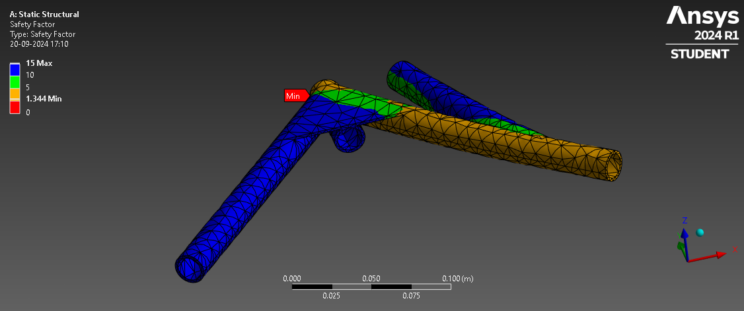

Load transfer
Lateral due to cornering
Longitudinal due to braking
Others(aerodynamics,engine torque,droop others)

Part
Upright and capiler mounts
Hubs
A-Arms and Toe Links

Wheel | Front  right | Front left | Rear  right | Rear  left
Vertical
Load(N)

G. STEERING:
To achieve minimum slip of wheels at corners we have
analyzed the turns of BIC circuit and its curves, 100%
Ackermann was considered to be the best solution for
low speed maneuvers. Steering ratio was decided to be
—-- and Ackerman percentage is analyzed on LOTUS as
Rack length:
IV. DESIGN VALIDATION PLAN
For validating the design of complete car we are relying
on physical testing while for validation of some
individual components we have identified methods. For
validation of suspension we have done FEA Analysis
on LOTUS as well as ANSYS, for validation of
powertrain components, brakes system, chassis and
aerodynamic components various FEA analysis have
been performed on FEA.

CONCLUSION
Taking our objectives into consideration we intend to
furnish a safe, economic and fast car whose primary
features include having a low center of gravity,
centralized mass and aerodynamic design. The design
of the car is robust and safe providing the rider

REFERENCE

DRAWINGS OF THE VEHICLE
SIDE VIEW:
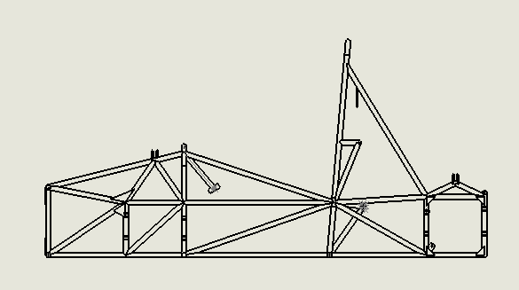

FRONT VIEW:

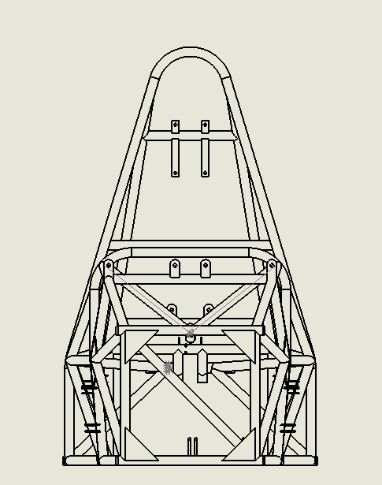

TOP VIEW:
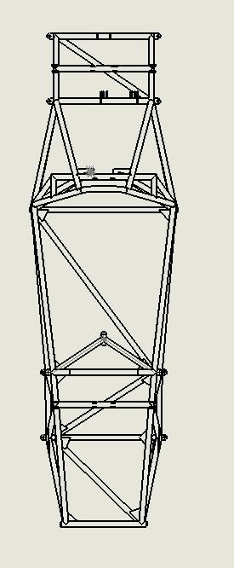

STEERING SYSTEM :

Parameters | Ackerman | Anti Ackerman | Parallel
Turning Radius | 10 | 6 | 8
Steering Response | 8 | 6 | 6
Stability at High Speed | 10 | 4 | 8
Steering Response | 8 | 6 | 6
Total | 36 | 22 | 28
> Steering Geometry Decision Matrix:
Max Points for one parameter: 10
Ackermann steering was chosen for its superior
performance in turning radius, steering response,
stability at high speeds, and overall efficiency,
making it the preferred choice for our vehicle.

Parameters | Rack and Pinion | Hydraulic powered | Recirculating ball | Worm and lever
Cost | 9 | 7 | 6 | 5
Steering Response | 9 | 8 | 6 | 5
Feedback | 9 | 8 | 5 | 6
Precision | 9 | 7 | 6 | 5
Total | 36 | 30 | 23 | 21
STEERING MECHANISM :
> Steering Mechanism Decision Matrix:
Max Points for one parameter: 10
Based on critical parameters such as cost,
steering response, feedback, and precision,
rack and pinion steering was chosen.
Its affordability, excellent responsiveness,
and superior feedback make it an ideal
choice for achieving optimal driving
performance and handling in our vehicle.

SUSPENSION SYSTEM

Wheel base |  | Rack travel
Track Width front , rear |  | Rack height | 37 mm
Turning radius |  | Rack length | 410 mm
Module of gear and pinion |  | Steering wheel diameter | 240 mm
No. of teeth in gear |  | Tie rods length | 250 mm each
No. of teeth in pinion |  | Steer angle
Steering ratio |  | Ackerman percentage

